**Practical No: 1**

**Complete Guide to Setting up Azure Virtual Desktops**

**Agenda:**

Section 3: Implement Azure Virtual Desktop Host pool

1. Method we can used to Setup AVD
2. Steps to setup Azure Virtual Desktop
3. Step by Step Implementation
4. Reference: - https://www.youtube.com/watch?v=Y5AB7AShdi0
5. **Method we can used to Setup AVD:**

AVD

On Premise

Using Vpn

ADDS

Azure Vm AD

Domain Service

1. **Steps to setup Azure Virtual Desktop:**
2. Create resource group
3. Create Virtual Network (internal)
4. Create a host pool
5. Create Azure virtual desktop (create a session host)
6. Assign an AD user
7. Add Role Assignment and Add members.
8. Add virtual desktop workspaces
9. Configure Virtual Desktop host pool
10. Log in to the Azure Virtual Desktop (Session Desktop).
11. **Step by Step Implementation to Setup Azure Virtual Desktop:**
12. Creating a New Azure Resource Group:

* In the Azure portal, select 'Resource groups' from the left-hand menu, then select '+ Add resource group'.
* In the 'Create resource group' blade, enter a name for your resource group and select the 'Subscription', 'Resource group location', and 'Pricing tier' fields. Then, select 'Create'.

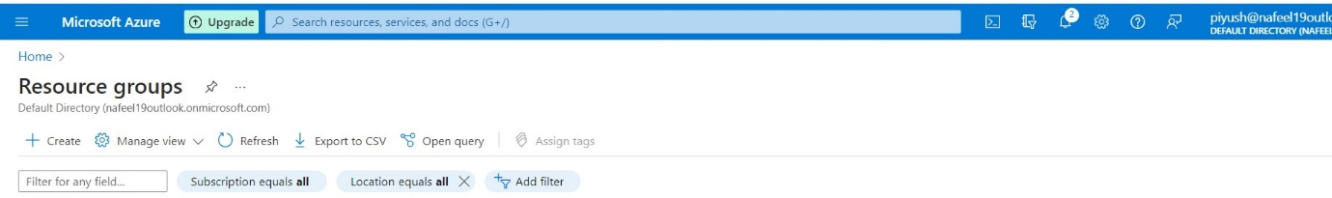

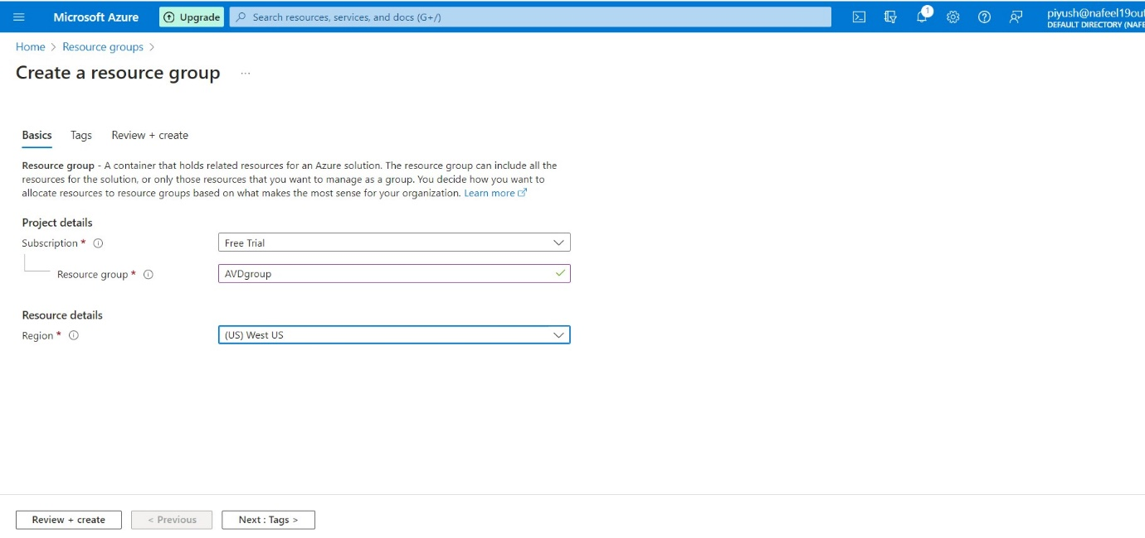

1. **Create a virtual network:**

We need to create a virtual network for the machines we are going to use later on. To do this, perform the following steps:

* Open Azure Portal as an Administrator.
* Search for Virtual Networks.
* 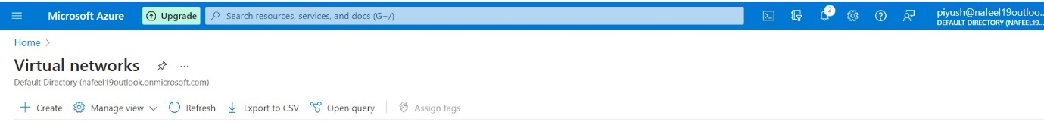Click on Create.
* Select your subscription type and add the existing created AVDgroup resource group that will have access to the network.
* 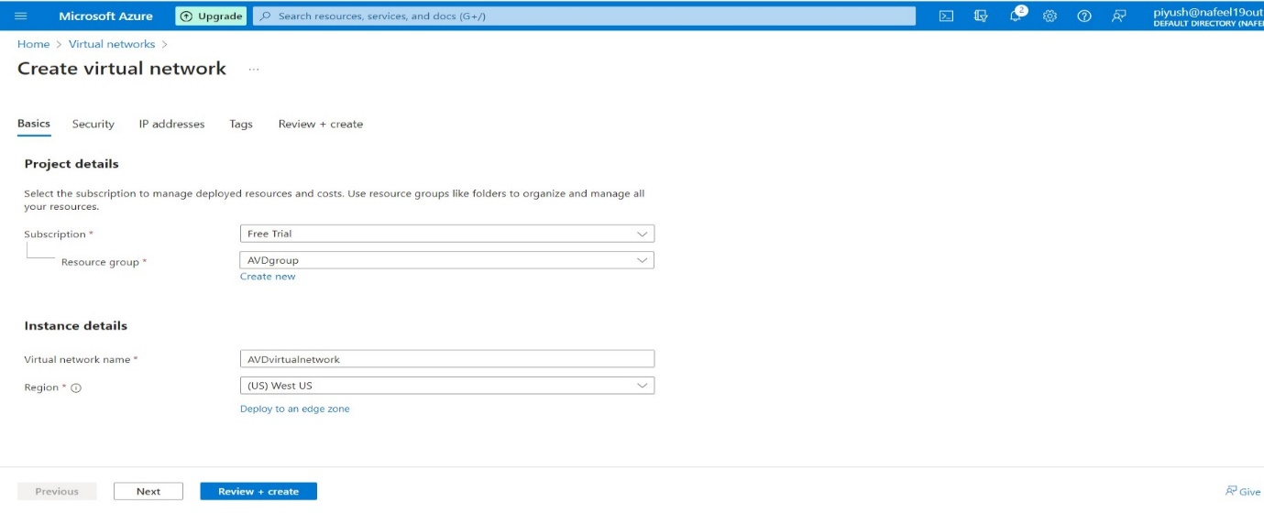Give a name to the virtual network and select the region.
* In the IP Addresses tab, leave everything as default.
* 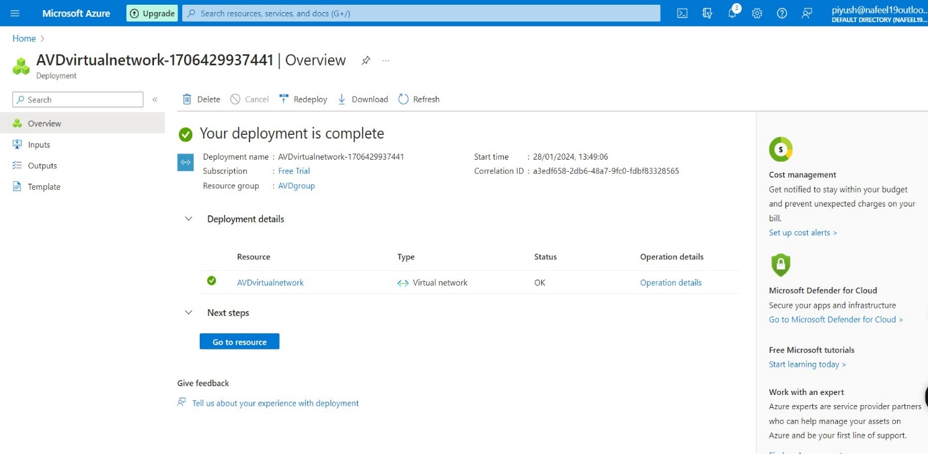Click to create virtual network

1. **Create a host pool:**

After the virtual network is configured, we need to create a host pool for the virtual machines. To do this, perform the following steps:

* + In Azure Portal, search for Azure Virtual Desktop.
  + 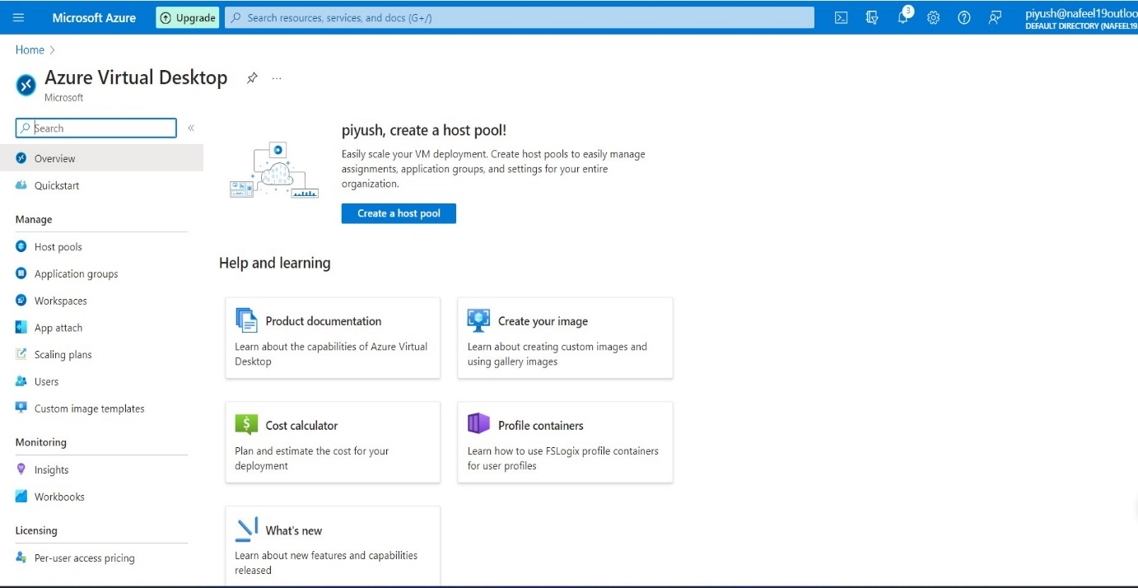Click on Create a host pool.
  + Select your subscription and choose the existing created resource group - AVDgroup you previously added for the virtual network.
  + Add a host pool name and location West US, keep same location for all the process in AVD.
  + Under the host pool type, select pooled.
  + Under the Load balancing, select Breadth-first
  + 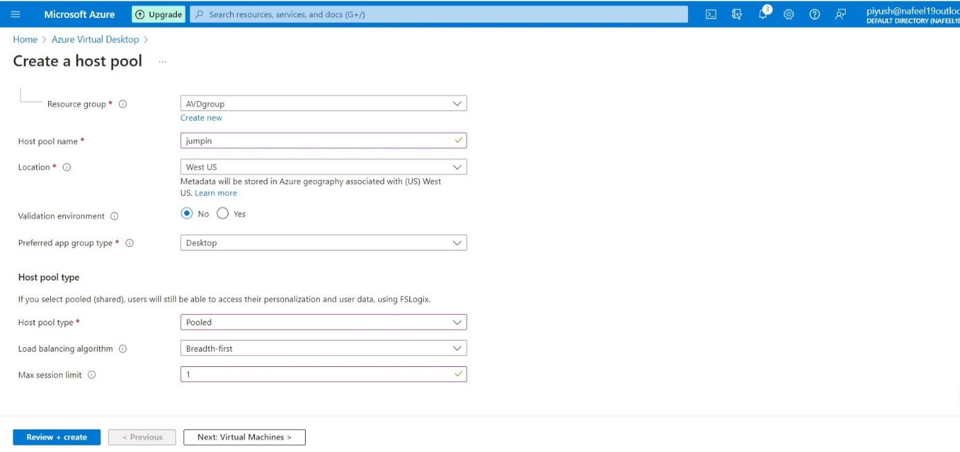Max session limit as per requirement.
  + Click Next.

1. **Create Azure virtual desktop (create a session host):**
   * In the Virtual Machines tab, select Yes to add a virtual machine.
   * Add existing created Resource group AVDgroup.
   * 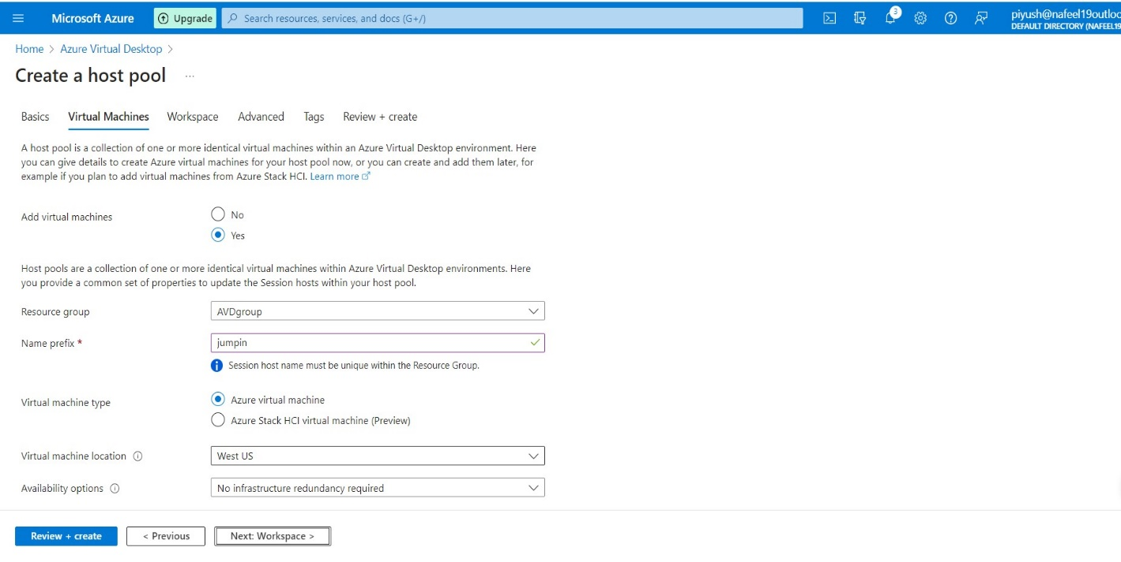Add a prefix name and location West US, keep same location for all the process in AVD.
   * Under Image as per requirement, windows 10 or 11.
   * 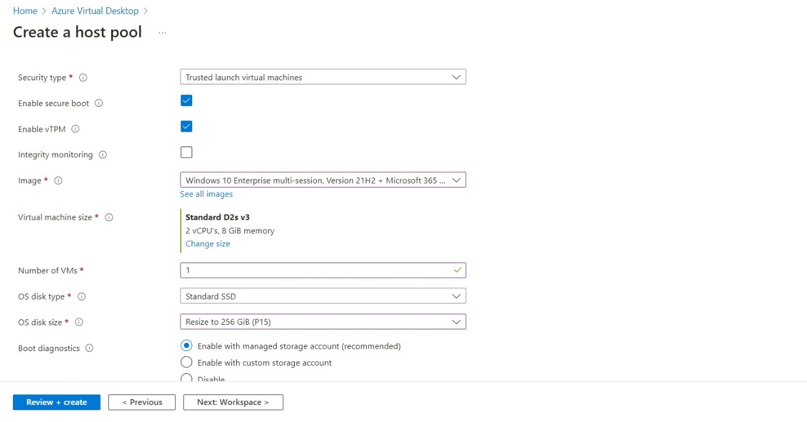You can add as many machines as you want in this step. We only added one and left everything else to standard.

* 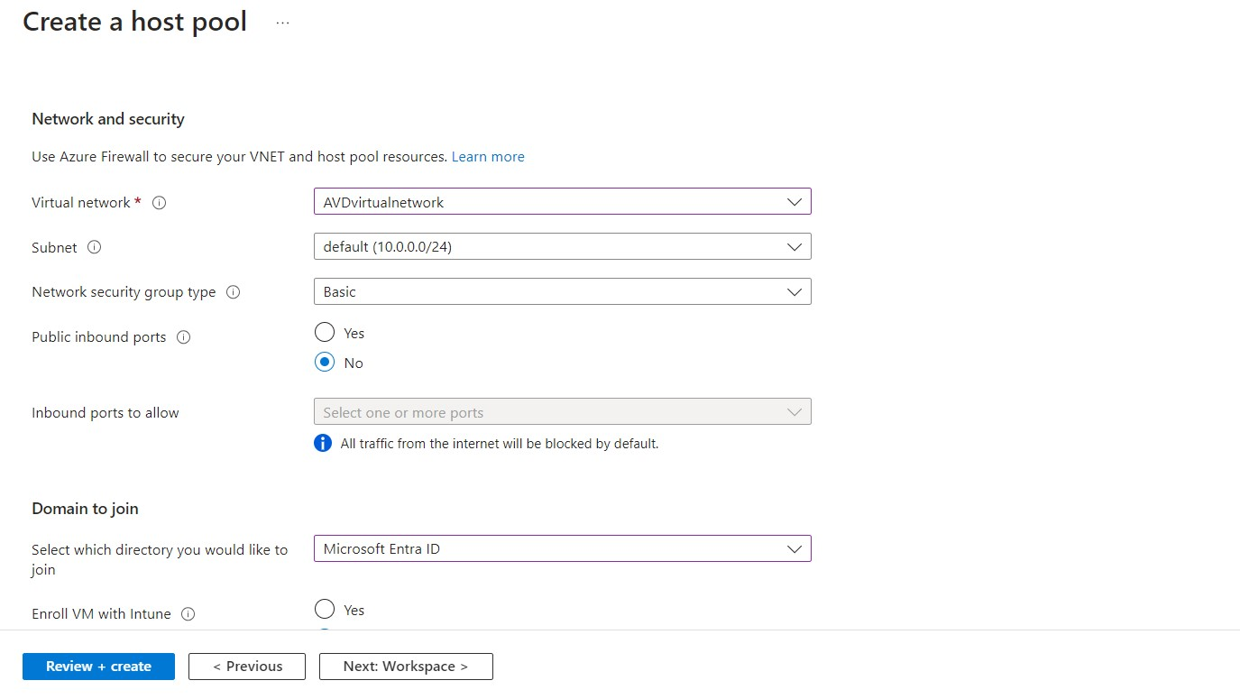Under the Network and security, make sure to select the previously created Virtual Network. No other network configurations are necessary.
* Under Domain to join.
* In our case, we don’t have a separate AD site, so we chose to join with the Azure Active Directory. We also went with the option to not enrol the VM with Intune.
* As a last step in this tab, create an administrator account so you can access the VM.
* 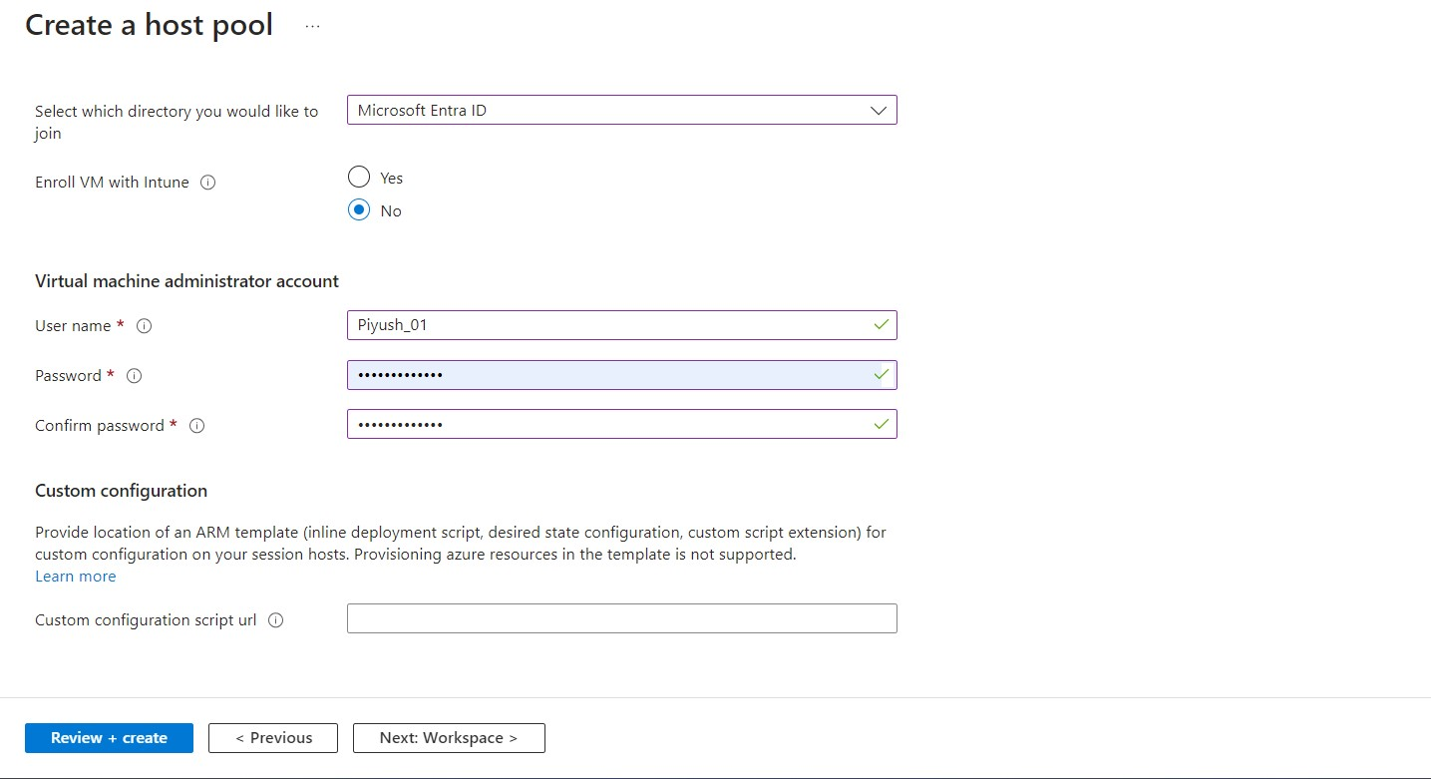Click Next.
* 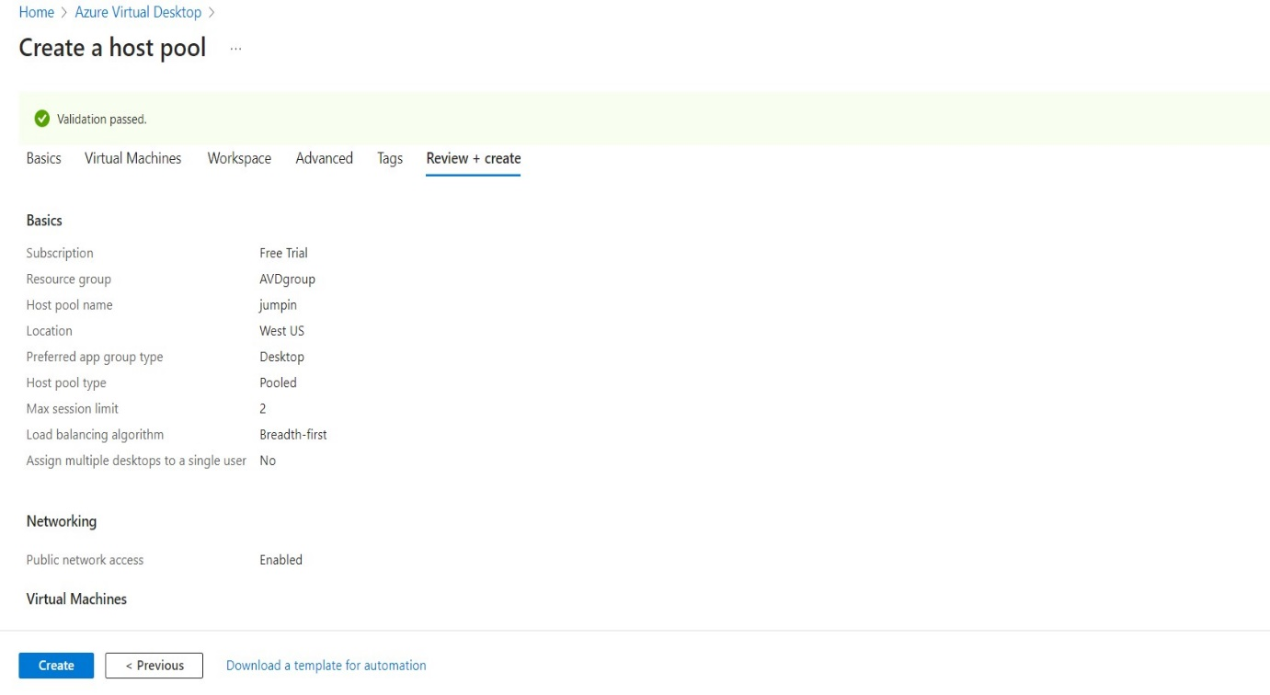Click to Create AVD Host pool.
* 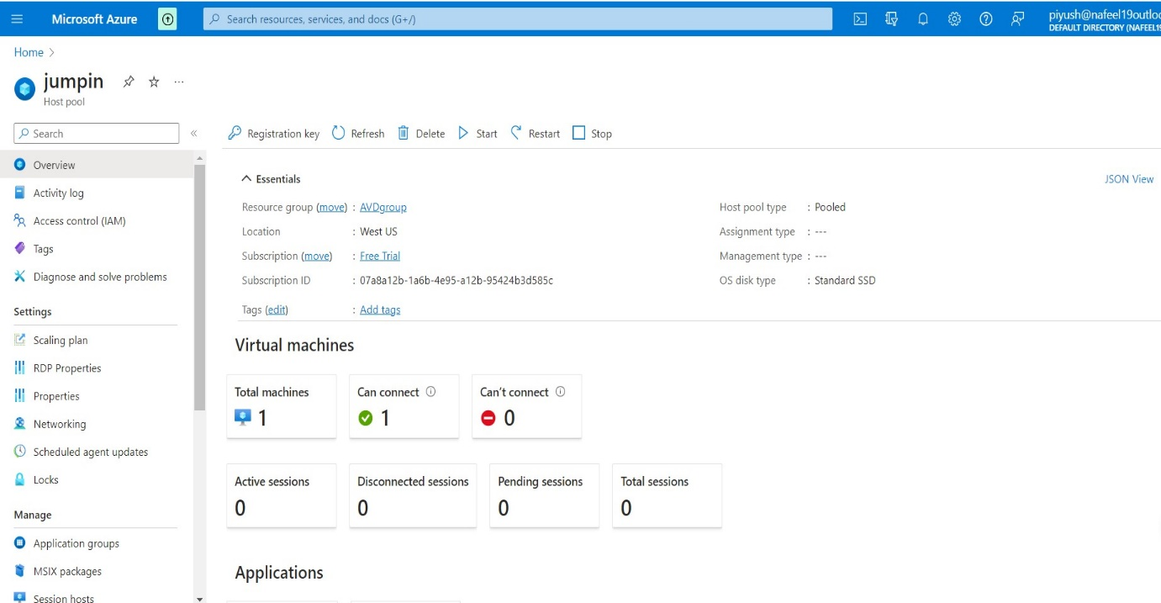Host pool is ready.

1. **Assign an AD user:**

* 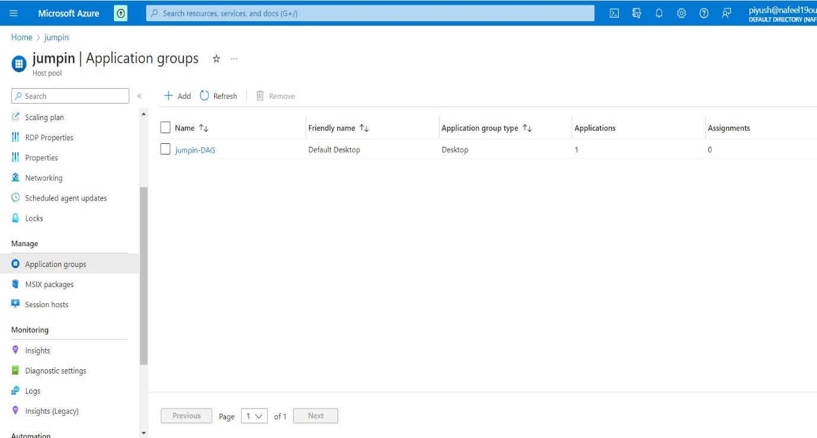In Manage → Application groups

**↑**

**Click on jumpin-DAG**

**←**

* In Application groups →Click on jumpin-DAG →In Manage →Assignments

**↑**

**Click to Add**

**←**

* 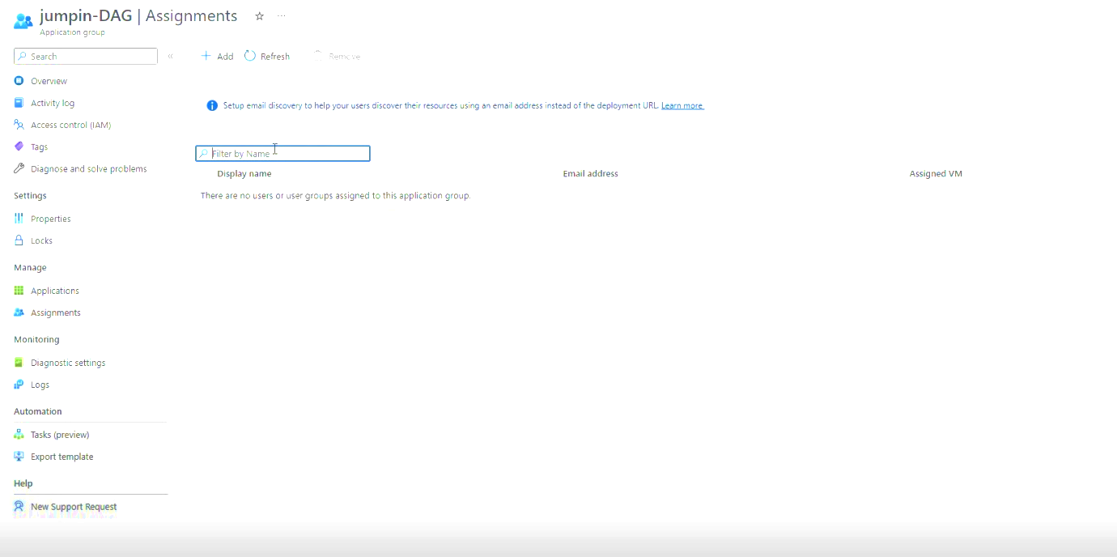Click to Add member to Access AVD.
* 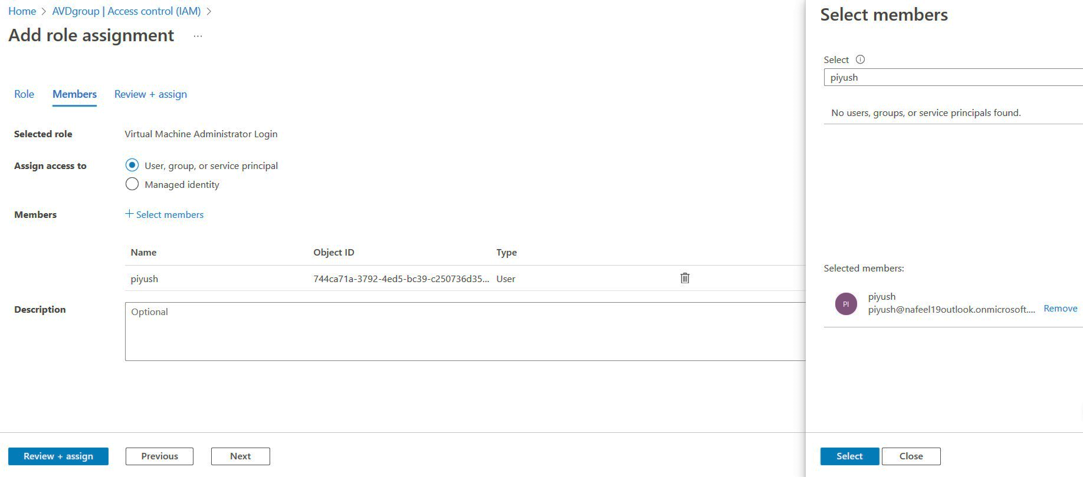Select Users as per requirements 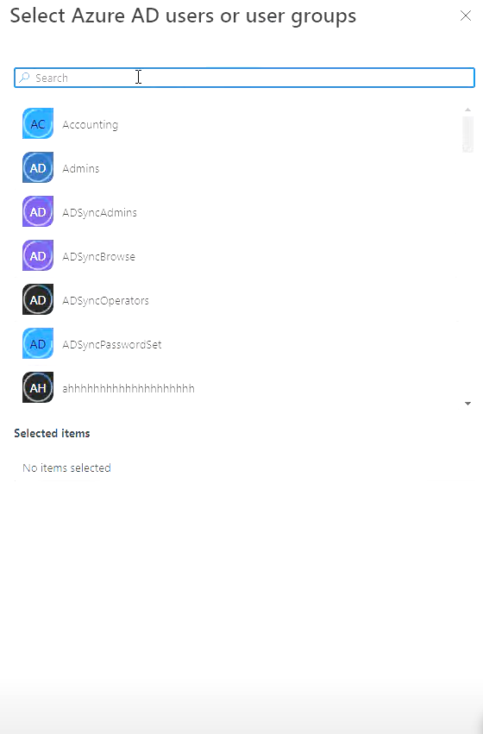

1. **Add Role Assignment and Add members:**

* To Access AVD, required some Additional Access Role.
* In the Azure portal, select 'Resource groups' which we Created AVDgroup.
* 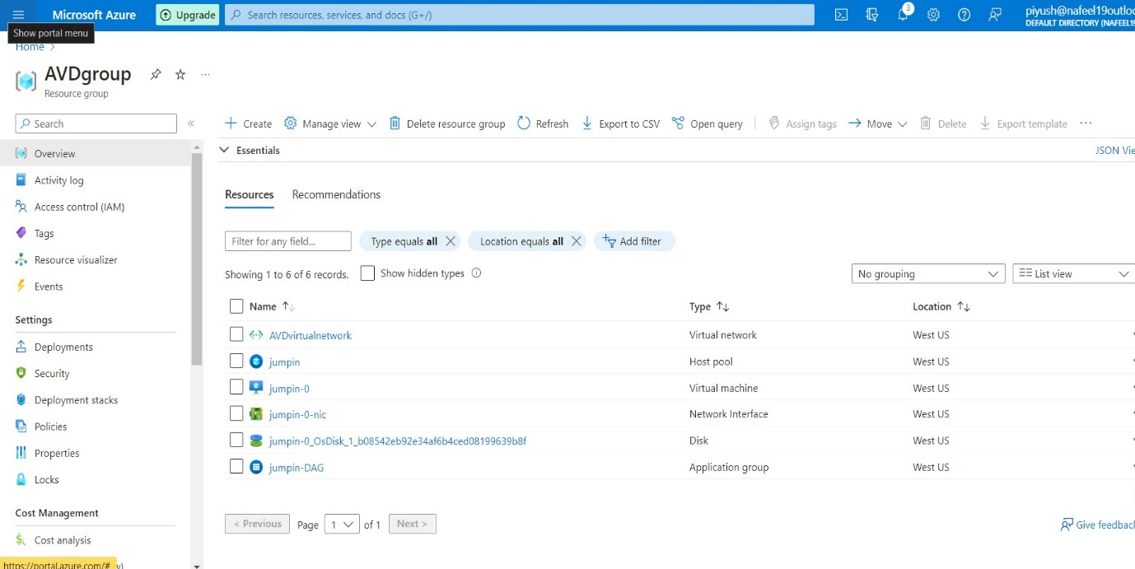Click on Access Control (IAM)

**←**

* 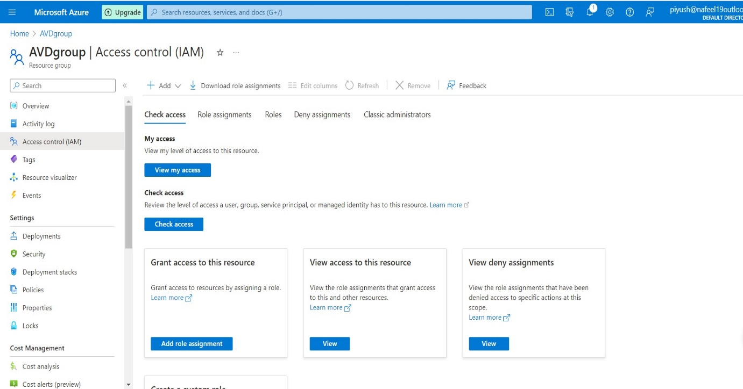Click to Add.

**↑**

* Click on Search → Virtual Machine User login →Select and Assign
* 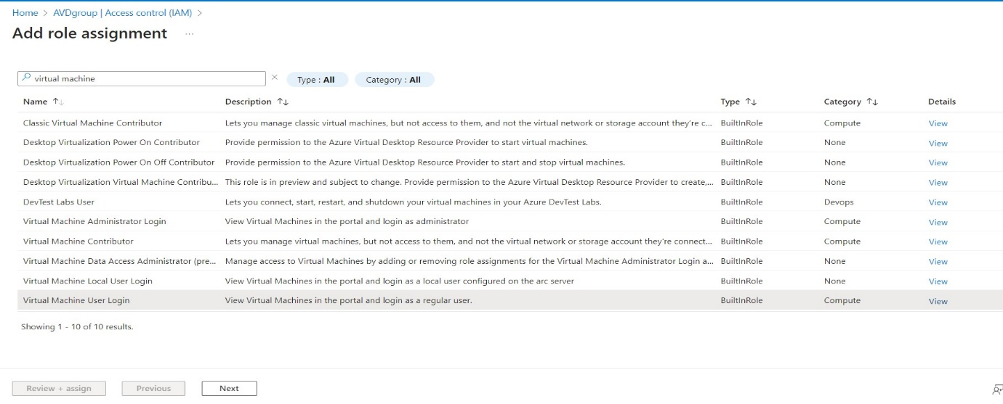Click to Next
* 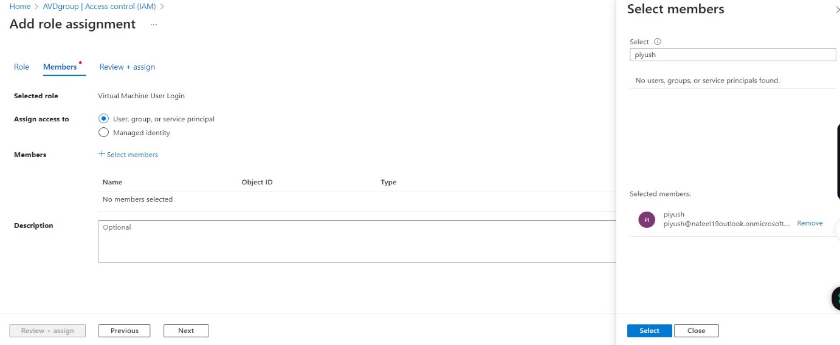Click to Select members

**← click on select**

* 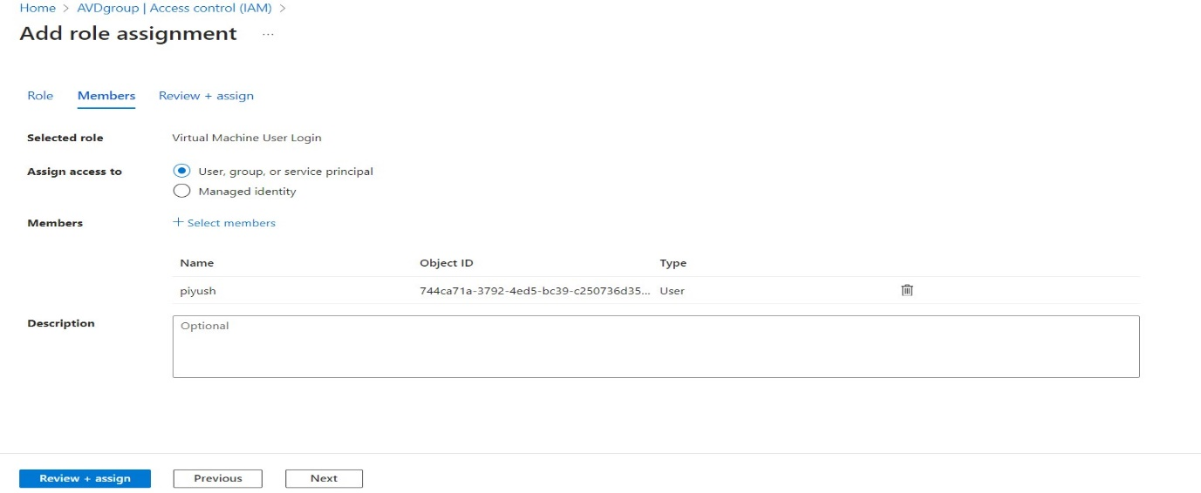Click to Assign
* Again, Same Step
* Click on Search → Virtual Machine Administrator Login → Select and Assign
* 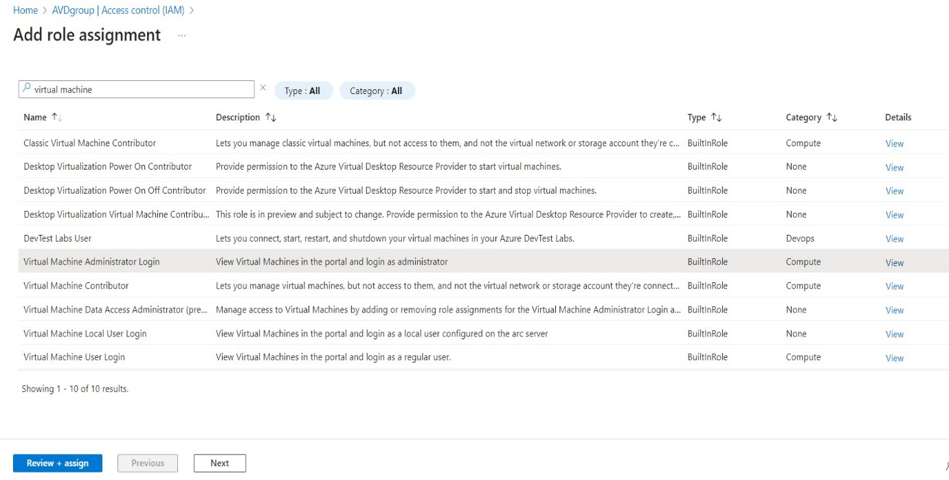Click to Next
* 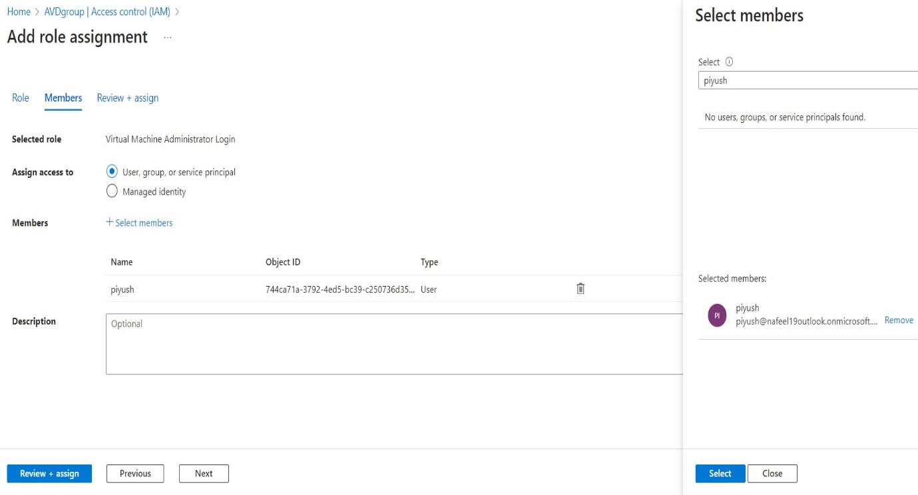Click to Select members And Assign

**← click on select**

1. **Add virtual desktop workspaces:**

* In Azure Portal, search for Azure Virtual Desktop.
* Click on Create a host pool.
* In Mange → Click on Workspace.
* 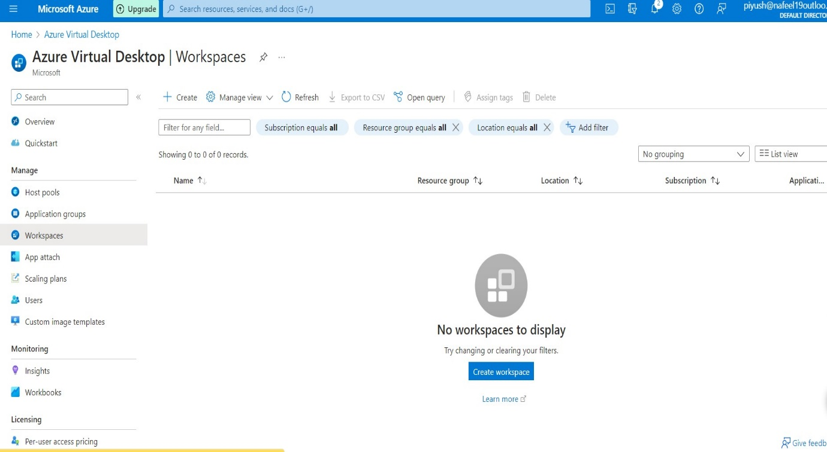Click to Create Workspace.

**↑**

**Click to Create**

* + Add existing created Resource group AVDgroup.
  + 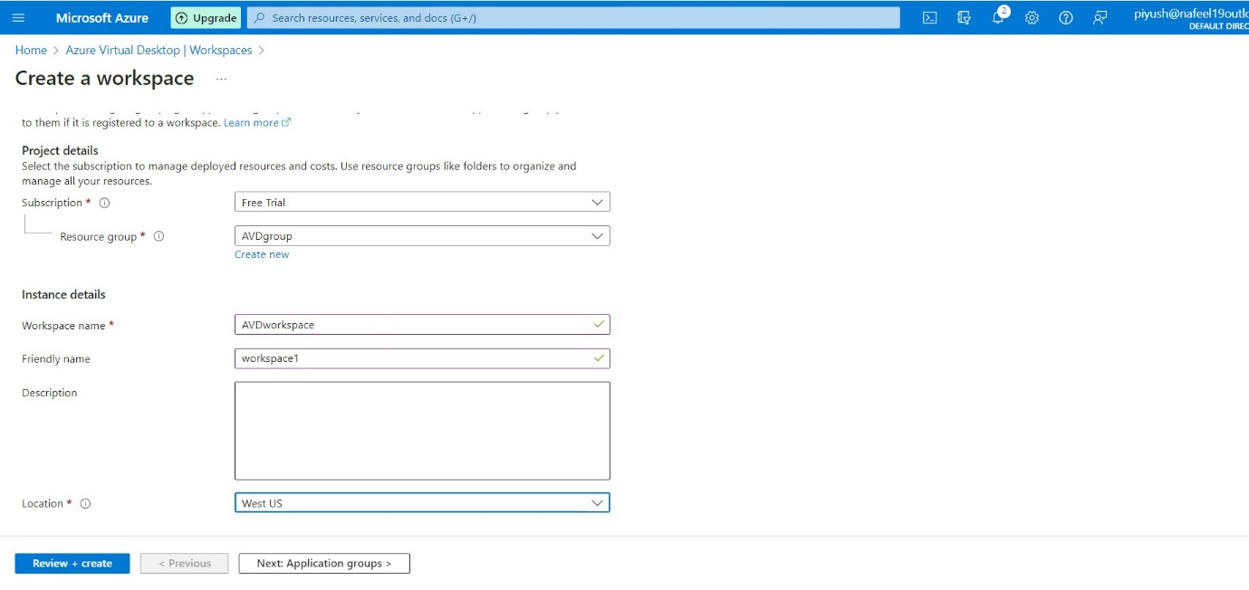Add a Workspace name and location West US, keep same location for all the process in AVD.
  + 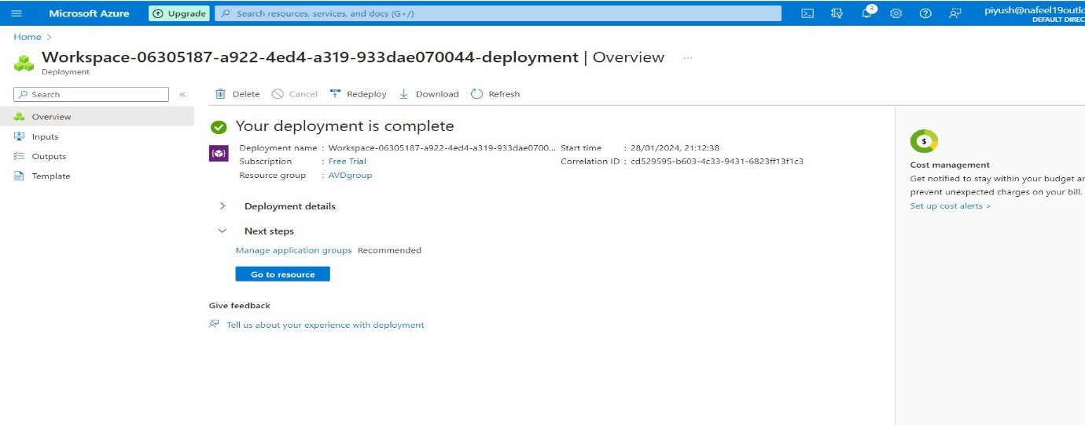Click to Create Workspace.
  + In Manage → Click on Application group.
  + 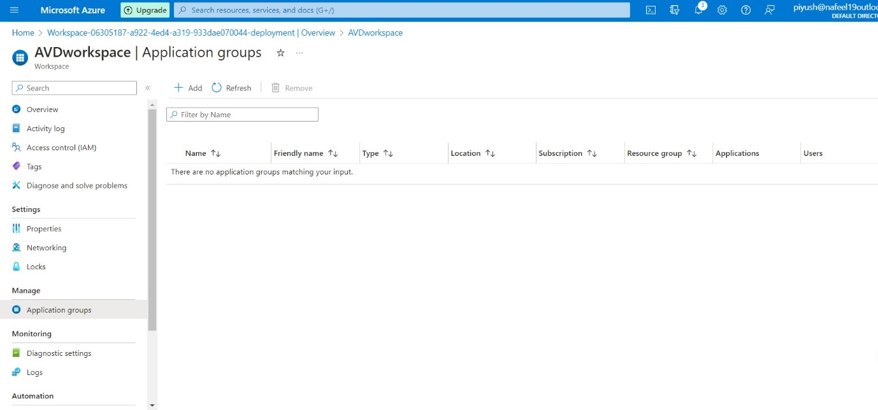Click on Add

**←**

**↑**

**Click to Add**

* + 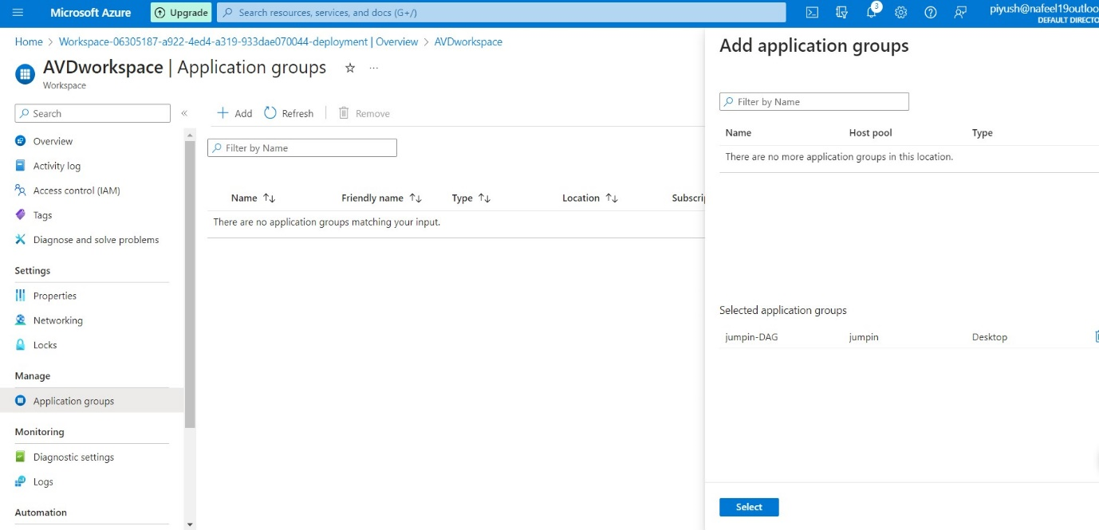Select that Application groups, which we Created by host pool.

**←**

1. **Configure Virtual Desktop host pools:**

* In Azure Portal, search for Azure Virtual Desktop.
* Click on Host pool we Created jumpin
* 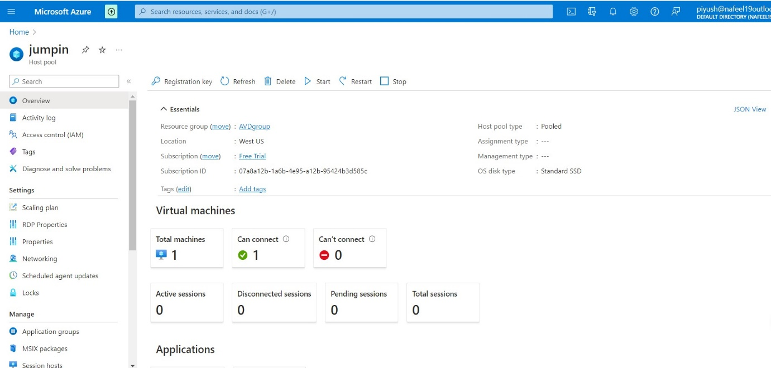In settings → Click RDP properties.

**←**

* 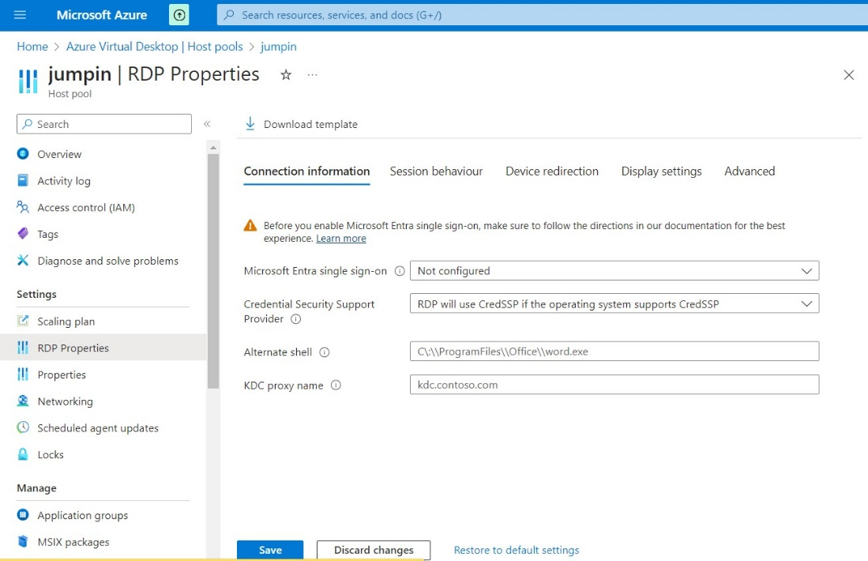Click on Advanced

**↓Click on Advanced**

* In Advanced type this → **;targetisaadjoined:i:1**
* 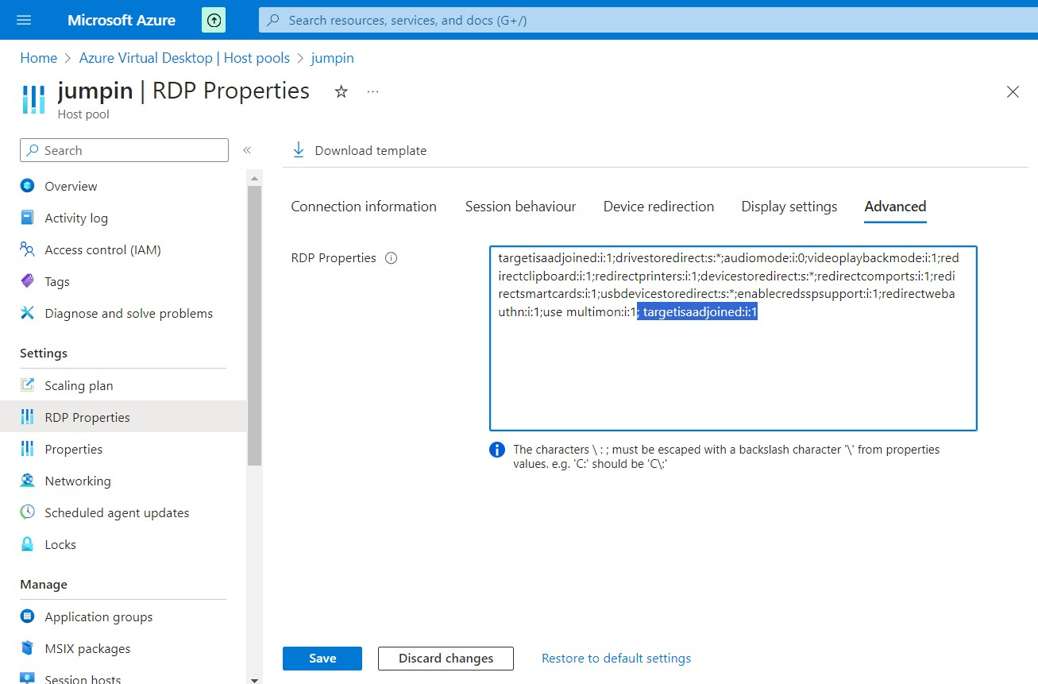Click to Save

1. **Log in to the Azure Virtual Desktop:**
   * After configuring your AVD host pool, you're ready to login to the Azure Virtual Desktop.
   * You can use the following link:

<https://rdweb.wvd.microsoft.com/arm/webclient/index.html>

* + Copy this link and past in new tab
  + 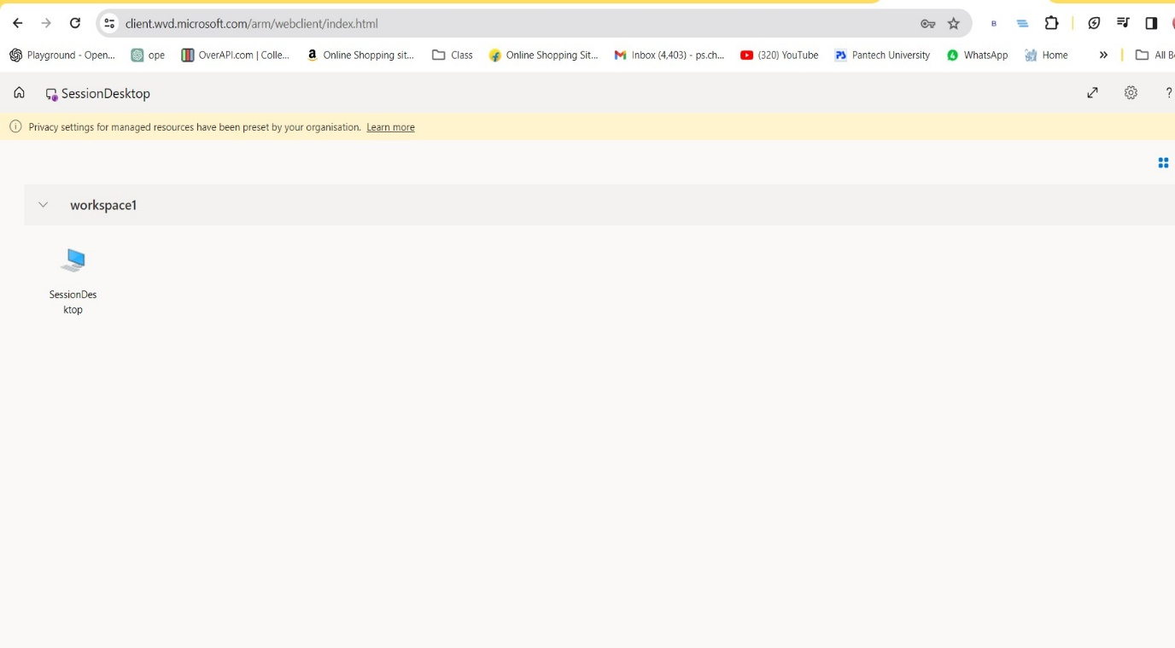Click on Session Desktop

**← click on SessionDesktop**

* Enter Username As per Selected AD User and Assign Role
* 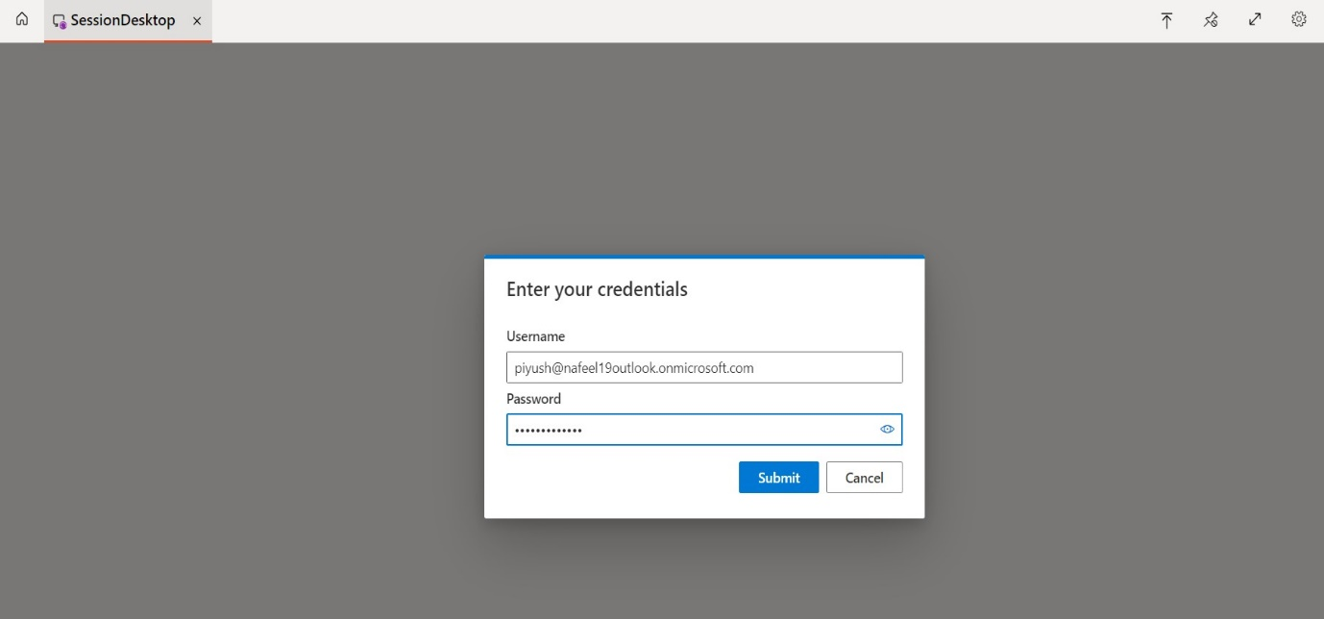Enter Password and Click to Submit.
* 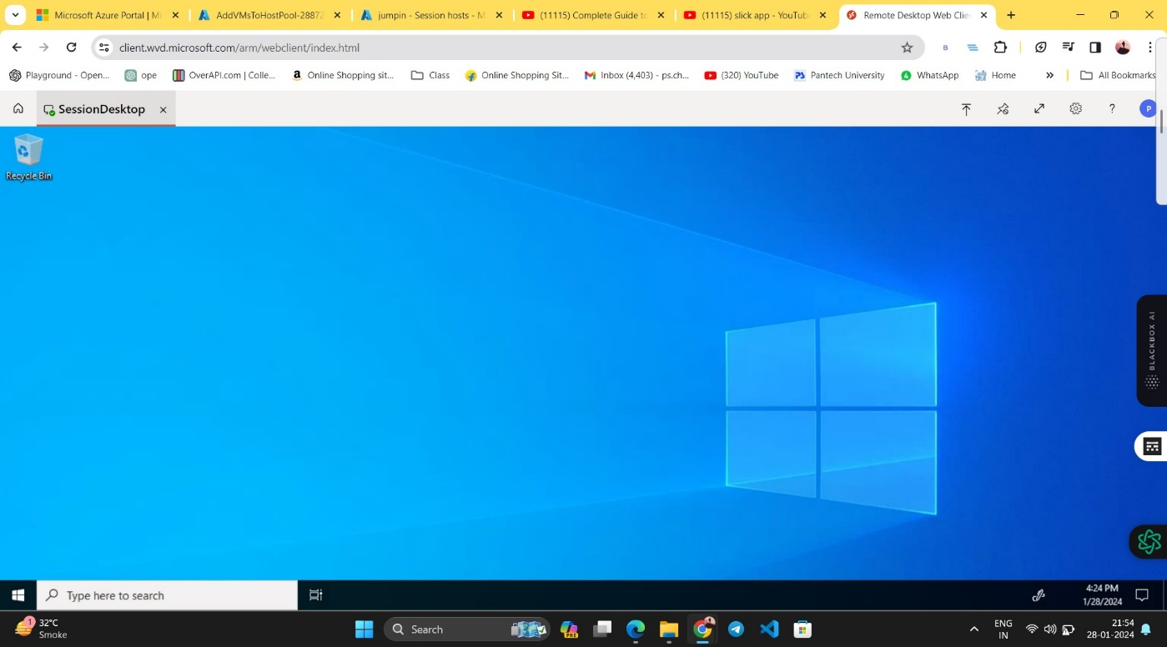 Now AVD Session Desktop Setup is Ready

Reference: - https://www.youtube.com/watch?v=Y5AB7AShdi0